**I Can Win**

1. Install Jenkins

2. Create a task which will perform the following:

* 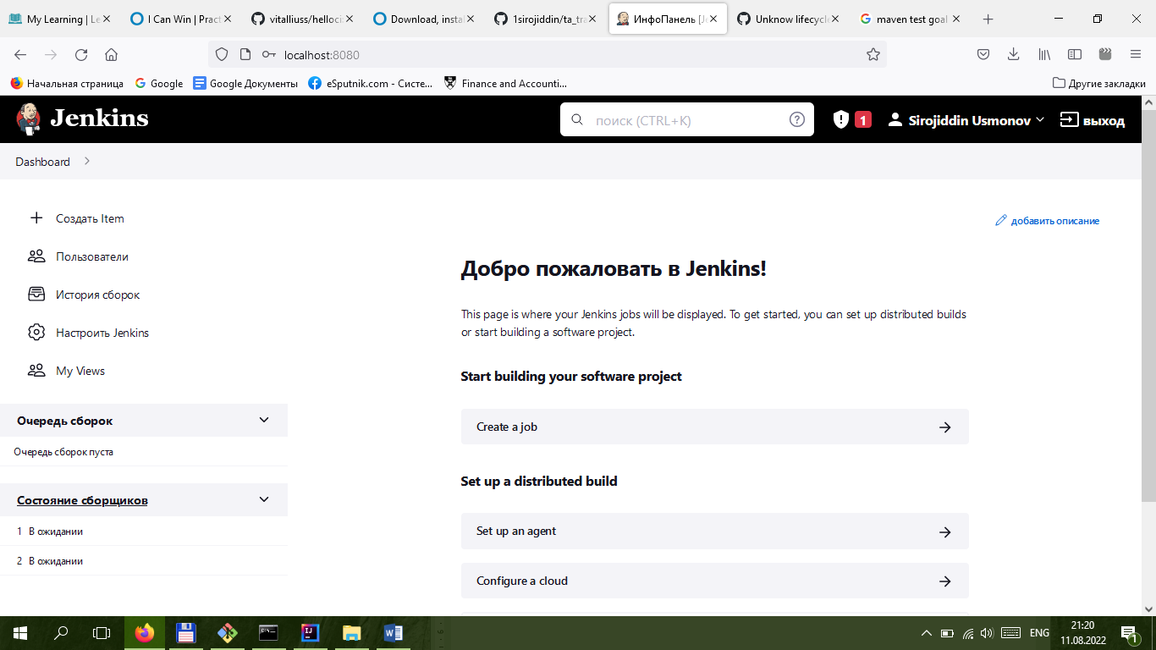Clone [the project](https://github.com/vitalliuss/helloci)

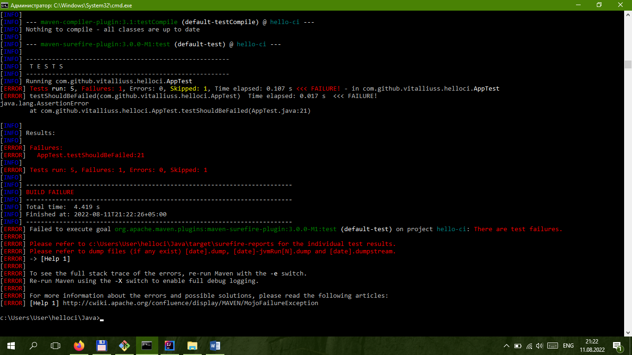**Launch tests from the project in Java directory with the help of mvn test goal**